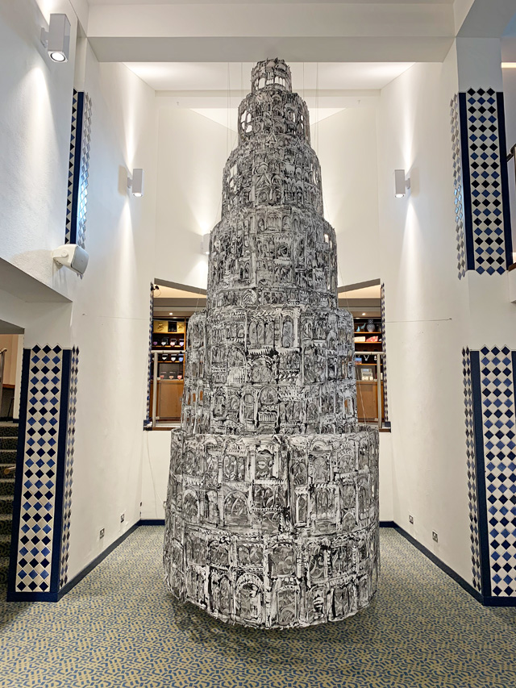
2010/2020s
Refugees have always been overlooked but are prevalent throughout history. Refugee artists have contributed to making our society beautiful. Through art as a form of expression, refugee artists have been able to tell the untold story of the refugee experience. Arts4Refugees calls to focus on post-conflict communities and the talent within it.

Each new cohort of refugees is commonly treated as exceptional. Refugees have become a fact of life in the modern world and have always maintained a presence in history.

Kinan Azmeh and Kevork Mourad have worked together through art and music to reflect on the Syrian revolution and its aftermath. They have created a capacity for which the refugee movement can be digestible to different people through art.

The Syrian Civil War that led to the Syrian Refugee Crisis began in 2011. Fractions of the 10-year war in Syria has punctuated our lives through the news. There has not been much afterthought. Over half of Syria’s pre-war population of 22 million has been forced to flee their homes in search of safety and opportunity. There are a total of 6.6 million Syrian refugees worldwide, more than a quarter of the world’s total refugee population. The crisis is entering its tenth year and has been exacerbated by the threat of Covid-19.

Kinan Azmeh is a Syrian composer and clarinettist. Kevork Mourad is a Syrian-Armenian visual artist. In 2020, Azmeh and Mourad performed an audio-visual performance called Home Within. In this work, art and music create reflection on the Syrian revolution and its aftermath. Rather than following a narrative, the artists document specific moments in Syria’s recent history and reach into their emotional content in a semi-abstract way. The cornerstone of the project was the single sound-image piece, ‘a sad morning, every morning,’ released in March 2012 by Azmeh.

Mourad’s has recently created Seeing Through Babel. It shows different languages, faiths, and cultures connecting. It reflects the wealth of civilisations.

Both artists have a developed a greater role for expressing the refugee experience. Both have experienced fleeing their country of origin. Both have become agents for social practice through their art.

Infographic:
https://www.canva.com/design/DAEjDRYRLCc/FVJnCbcNHYdESZJTmX4arw/view?utm_content=DAEjDRYRLCc&utm_campaign=designshare&utm_medium=link&utm_source=publishsharelink

Instagram style: https://www.canva.com/design/DAEixb2k1vk/vnUqRG6dFWsGPMWrA8en1w/view?utm_content=DAEixb2k1vk&utm_campaign=designshare&utm_medium=link&utm_source=publishsharelink

